

Bí Cineálta Policy to Prevent and Address Bullying Behaviour 2026

Mission Statement
At Greenhills Community College, we promote academic excellence, in a respectful and inclusive environment, where learners achieve their unique potential. We encourage a culture of curiosity, helping our students flourish into responsible individuals, who embody the core values of our school.
We Care. We Prepare. We Achieve.
Aims and Objectives

- To foster the growth of the students at the College morally, socially, academically, emotionally and physically regardless of their social background, education achievements or intellectual ability.
- To educate students from all religious and cultural backgrounds.
- To provide a comprehensive curriculum to assist each student to make the most of their talents, skills and abilities.
- To operate the College as a partnership between the staff, students, parents and the wider community in accordance with the Education Act 2018 and the Education Welfare Act 2023.
- We aim to establish an inclusive work environment free from discrimination in accordance with the Equal Status Act 2018.

Background
Greenhills Community College, an all-boys second-level school, was opened in 1970 to serve the developing area of Southwest Dublin. The college seeks to stimulate and foster the physical, intellectual, moral, emotional and spiritual growth of the students. Parents who choose Greenhills Community College as a second-level school for their children do so in the knowledge that the college will value each student for his own personal gifts. The college has continuously evolved to meet the changing needs of the school, ensuring it is well-equipped to prepare students for a successful future. The college is multi-denominational and welcomes students from all backgrounds and traditions.

Introduction

The Board of Management of Greenhills Community College has adopted the following policy to prevent and address bullying behaviour. This policy fully complies with the requirements of Bí Cineálta: Procedures to Prevent and Address Bullying Behaviour for Primary and Post-Primary Schools 2024.

The board of management acknowledges that bullying behaviour interferes with the rights of the child as set out in the United Nations Convention on the Rights of the Child. We all, as a school community, have a responsibility to work together to prevent and address bullying behaviour and to deal with the negative impact of bullying behaviour. We are committed to ensuring that all students who attend our school are kept safe from harm and that the wellbeing of our students is at the forefront of everything that we do. We recognise the negative impact that bullying behaviour can have on the lives of our students, and we are fully committed to preventing and addressing bullying behaviour.

We confirm that we will, in accordance with our obligations under equality legislation, take all such steps that are reasonably practicable to prevent the harassment of students or staﬀ on any of the nine grounds specified: gender, civil status, family status, sexual orientation, religion, age, disability, race and membership of the Traveller community.

Definition of bullying

Bullying is defined in Cineáltas: Action Plan on Bullying and Bí Cineálta: Procedures to Prevent and Address Bullying Behaviour for Primary and Post-Primary Schools as targeted behaviour, online or oﬄine that causes harm. The harm caused can be physical, social and/or emotional in nature. Bullying behaviour is repeated over time and involves an imbalance of power in relationships between two people or groups of people in society.
While isolated or once-off incidents of intimidation, aggression or intentional negative behaviour may not fall strictly within the definition of 'bullying behaviour', Greenhills Community College reserves the right to decide whether to:
- regard them as precursors of bullying behaviour and to apply this policy to prevent further escalation or to
- deal with them in accordance with the Greenhills Community College Code of Behaviour and Greenhills Community College's Disciplinary Procedures.
However, placing a once-off offensive or hurtful public message, image or statement on a social network site or other public forum, where that message, image or statement can be viewed and/or repeated by other people will be regarded as bullying behaviour (zero tolerance).

The detailed definition is provided in Chapter 2 of the Bí Cineálta procedures.

Each school is required to develop and implement a Bí Cineálta policy that sets out how the school community prevents and addresses bullying behaviour. Strategies to deal with inappropriate behaviour, that is not bullying behaviour are provided for within the school’s Code of Behaviour.

Section A: Development/review of our Bí Cineálta policy to prevent and address bullying behaviour
All members of our school community were provided with the opportunity to input into the development/review of this policy.

 | Date consulted | Method of consultation
School Staﬀ | 18th of March 2025  26th of March- 15th of April 2026 | Staff half day planning and questionnaire on MS forms  Policy emailed to all staff and asked for feedback.
Students | 2nd-11th of April 2025  13th –17th of April 2026 | MS forms questionnaire in SPHE classes.  Student friendly policy competition- Assemblies with each year group to explain the competition.  Student Council review
Parents | 19th of March 2025  4th of April 2025  13th- 17th of April 2026 | Questionnaire completed by members of the parents’ association.  Parents asked to complete MS forms questionnaire through the iClass app.  Policy emailed to members of the Parents association and asked for feedback
Board of Management | 20th of May 2025  30th of April 2026 | Board of management meeting  Board of management meeting
Wider school community as appropriate. E.g. Bus drivers | 7th May 2025  15th of April 2026 | Questionnaires given to Centra manager, two school bus drivers and two school bus escorts  Questionnaires given
Date policy was approved:
Date policy was last reviewed: April 2026

Section B: Preventing Bullying Behaviour

This section sets out the prevention strategies that will be used by the school. These include strategies specifically aimed at preventing online bullying behaviour, homophobic and transphobic bullying behaviour, racist bullying behaviour, sexist bullying behaviour and sexual harassment as appropriate (see Chapter 5 of the Bí Cineálta procedures):
- In Greenhills Community College, there is a Zero Tolerance approach to bullying behaviour. All school staff are responsible for fostering and upholding a positive school culture in which bullying behaviour is not tolerated. Staff must take a consistent and proactive approach to preventing and addressing bullying behaviour. This is helped by creating a safe and consistent learning environment within the classroom.
- Reasonable measures are taken to ensure student safety and appropriate supervision during school and related activities. (subject to the resources provided by the Department of Education & Skills) There are a range of organised activities at lunchtimes to cater for different interests, i.e. Cooking club, friendship club, mentoring programme, art club, enterprise club, student council meetings etc.
- There is a focus on building empathy, respect, and resilience in students.
- Celebrating diversity is of upmost importance to Greenhills Community College, and the contributions of all students are celebrated. For example, SIP and attendance awards, student council, Ethos ambassadors, student mentors, green schools, digital committees, etc.
- Students are provided with opportunities to understand the causes and effects of all types of bullying behaviour, particularly through the implementation of the SPHE curriculum.
- The updated SPHE specifications aim to empower students to build respectful, healthy relationships with themselves and others. The RSE strand encourages exploration of relationships and human sexuality, promoting understanding of diversity and helping to reduce gender and identity-based bullying, sexism, and sexual harassment.
- Prevention and awareness raising measures also deal explicitly with cyber-bullying through educating students about appropriate online behaviour, how to stay safe while online and through developing a culture of reporting any concerns about or incidents of bullying behaviour to a member of the teaching staff. The Digital Media Literacy curriculum in particular teaches students about responsible online behaviour and digital citizenship. The school is also part of the Webwise national programme.
- Greenhills Community College has adopted a whole school approach (involving management, staff, parents/guardians and students) to prevent and combat bullying behaviour. Greenhills Community College is committed to engaging with parents/guardians through involving them in the development of policies and practices to address bullying behaviour to ensure that they understand how the school deals with bullying behaviour, and to provide them with reliable information on how they may contribute towards combating bullying behaviour. (Emphasis on the importance of students reporting bullying behaviour)
- Greenhills Community College takes account of the needs of students with AEN. This involves supporting inclusion and diversity, focusing on developing social skills, paying particular attention to student induction, and cultivating a school culture that respects everyone and values helping one another.
- The wellbeing of the school community is central to all the schools policies and plans. The Code of behaviour, digital learning and acceptable use policy, AEN, RSE and Wellbeing policy support the implementation of our school’s Bí Cineálta policy.
- Each year group is introduced to the Guidance Service. First years partake in a one-week transition programme and a mentoring programme with transition years throughout the year. Students who require extra support are involved in the Check and connect programme.
- The Tutor and Year Head will get to know every student throughout their time in the school and frequently emphasis the importance of letting them know if there is a problem - for them or for others in the class.
- The Care Team is made aware of any possible bullying in Greenhills Community College.
- In drafting the Bí Cineálta policy, students were involved in a “Student Friendly” Bí Cineálta poster competition. This is displayed around the school building and included in student journals. Please see the winning poster on the following page.

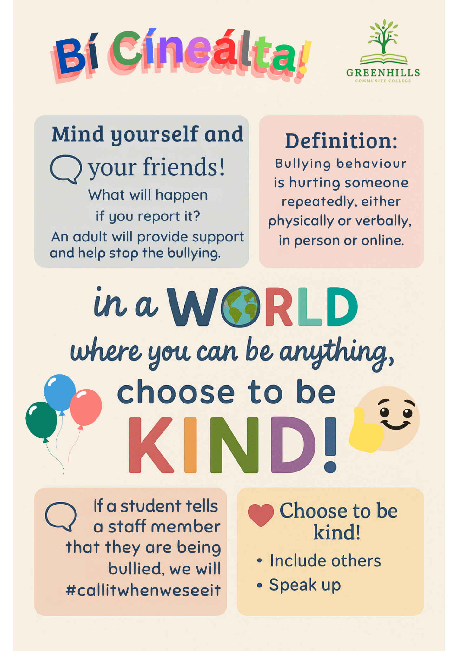

Supervision and Monitoring

The school has the following supervision and monitoring policies in place to prevent and address bullying behaviour (see Chapter 5 of the Bí Cineálta procedures):

- Every effort will be exhausted to ensure the supervision of every student's interaction in every area of the school. However, subject to the resources provided by the Department of Education & Skills, the Board of Management endeavors to ensure that appropriate supervision and monitoring policies and practices are in place both to prevent and deal with bullying behaviour and to facilitate early intervention where possible.
- Supervision takes place before school in the canteen.
- There is adequate supervision during all breaks and lunchtimes, both inside the canteen and out in the school yard.
- Teachers are all expected to be at their classrooms before students arrive so that supervision begins from the start of every class.
- School trips and outings are supervised by teachers in the appropriate student-teacher ratio.
- During exam times, supervision is provided by teachers throughout the exam period and at break times.

Section C: Addressing Bullying Behaviour
The teachers with responsibility for addressing bullying behaviour are as follows:
Principal, Deputy Principal, Junior Year Head, Senior Year Head and AEN coordinator.

When bullying behaviour occurs, the school will:
- ensure that the student experiencing bullying behaviour is heard and reassured
- seek to ensure the privacy of those involved
- conduct all conversations with sensitivity
- consider the age and ability of those involved
- listen to the views of the student who is experiencing the bullying behaviour as to how best to address the situation
- take action in a timely manner
- inform parents of those involved

The steps that will be taken by the school to determine if bullying behaviour has occurred, the approaches taken to address the bullying behaviour and to review progress are as follows (see Chapter 6 of the Bí Cineálta procedures):

Determining if Bullying behaviour has occurred:

- Student reports of bullying behaviour should be made primarily to the Year Head/Principal/Deputy Principal but may also be made to any teacher or any member of staff.
- Staff and parent reports of bullying behaviour should be submitted by email to the Year Head, Deputy Principal, or Principal. If a report is made in person, it should be followed up with a detailed email to ensure there is an official record.
- The Year Head/Principal/Deputy Principal will investigate the initial report.
- All records of bullying behaviour shall be maintained in accordance with the school's record keeping policy and with data protection regulations.
- All reports, including anonymous reports, of bullying must be investigated and dealt with by the Year Head/Principal/Deputy Principal.
- The student who is experiencing bullying behaviour will be interviewed and assured that they are entitled to a school environment free of any bullying behaviour and will be encouraged to report any further incidents if they should occur. This may be by direct student-teacher communication or through a parent/guardian. This may also involve keeping a 'diary' or written record, taking screenshots of further incidents.
- A student reporting bullying behaviour may ask that a member of staff does nothing about the behaviour other than “look out” for them. Where this occurs, the staff member will deal with this sensitively and speak with the student to work out together what steps can be taken to address the matter and how their parents will be informed of the situation.

- Parents may also make schools aware of bullying behaviour that has occurred and specifically request that the school take no action. Parents should put this request in writing to the school or be facilitated to do so where there are literacy, digital literacy, or language barriers. However, while acknowledging the parent’s request, schools may decide that, based on the circumstances, it is appropriate to address the bullying behaviour.
- If action is to be taken, those allegedly displaying bullying behaviour will be interviewed and may be asked for a written account of the alleged incident(s). All evidence will be requested from all possible sources.
- A restorative approach will be used when investigating incidents. The emphasis will be on seeking a change in behaviour and supporting all students involved.

Addressing the bullying behaviour:

- If it is established that bullying behaviour has occurred, the Year Head/Principal/Deputy Principal shall keep an appropriate written record which will assist his/her efforts to resolve the issues and restore, as far as is practicable, the relationships of the parties involved.
- They will inform the Care Team at the next weekly meeting.
- Where bullying behaviour is determined, the student(s) displaying bullying behaviour will be informed that their behaviour is a serious breach of our Bí Cineálta policy. The parents/guardians will be informed and/or invited to an interview in the school.
- The parents/guardians of the student experiencing bullying behaviour will also be informed and, where it is deemed necessary by the Care Team, may be offered further help from the school.
- Counselling and/or restorative practice as deemed appropriate by the Care Team will be offered.
- Following investigation and consideration, sanctions could be imposed in line with the school's discipline procedures (see Ladder of Referral in Greenhills Community College Code of Behaviour).
- All students involved will be appropriately supported.

Reviewing progress:

- The Year Head/Principal/ Deputy Principal must engage with the students and parents/guardians involved, no more than 20 school days after the initial discussion, to review progress following the initial intervention.
- If the bullying behaviour has not ceased, the Year Head/Principal/Deputy Principle will review the strategies used in consultation with the students and parents and agree to meet again over an agreed timeframe until the bullying behaviour has ceased.
- Records kept will document the review (and dates) with students and their parents to determine if the bullying behaviour has ceased. The date that it has been determined that the bullying behaviour has ceased will also be recorded.
- Ongoing supervision and support may be needed for the students involved even where bullying behaviour has ceased.
- Where it becomes clear that the student who is displaying bullying behaviour is continuing to display the behaviour, the school may use strategies to deal with inappropriate behaviour as provided for within the school’s Code of Behaviour.
  - Parents/guardians may be invited to an interview with the Year Head, Principal, or Deputy Principal. In such cases, parents/guardians will be reminded of the content of this policy.
  - Reference may be made to the section under 'Bí Cineálta' in the Code of Behaviour.
  - Serious misdemeanors and repeated offences will be referred to the principal and to the Board of Management.

The school will use the following approaches to support those who experience, witness and display bullying behaviour (see Chapter 6 of the Bí Cineálta procedures):
- School staff will be fair and consistent in their approach to addressing bullying behaviour.
- Action will be taken in a timely manner.
- Both the student who is experiencing bullying behaviour and the student who is displaying bullying behaviour will be supported.
- The student who is experiencing bullying behaviour will be engaged with without delay so that they feel listened to, supported, and reassured.
- The student who is experiencing bullying behaviour will be involved in deciding what actions will be taken, where appropriate.
- The parents of the parties involved will be contacted at an early stage to inform them of the matter and about the actions to be taken to address the behaviour. In circumstances where a student expresses concern about their parents being informed, the school will develop an appropriate plan to support the student and for how their parents will be informed. (Any communication barriers will be considered.)
- All conversations will be conducted with sensitivity, and the privacy of those involved will be considered.
- The programme of support for students experiencing/displaying bullying behaviour in Greenhills Community College is as follows:
  - A programme of support for students will be put in place, in line with the recommendations from the Care Team.
  - A programme of ongoing support for those students involved in bullying behaviour will be part of the school's intervention process. Students who engage in bullying behaviour may need counselling to help them learn other ways of meeting their needs and managing relational difficulties without violating the rights of others, or they may need activities to help them develop maturely or increase feelings of self-worth. Refer to Guidance Counsellor or outside agencies if appropriate.
  - Students who observe incidents of bullying behaviour will also receive ongoing support if required.

All bullying behaviour will be recorded. This will include the type of behaviour, where and when it took place, and the date of the engagement with students and parents. The actions and support agreed to address bullying behaviour will be documented. If bullying behaviour is a child protection concern the matter will be addressed without delay in accordance with Child Protection Procedures for Primary and Post-Primary Schools.
Referral of serious cases

  - In relation to bullying in schools, the children's first national guidance document 2017, provides that in situations where the bullying behaviour is serious and where the behaviour is regarded as potentially abusive, a referral may need to be made to Tusla or An Garda Síochána. Bullying behaviour may become a child protection concern when it results in significant physical or emotional harm, or where it becomes a persistent and severe problem, and measures taken to address it are not effective.
  - If there is doubt about whether bullying behaviour is a child protection concern, the Designated Liaison Person should contact Tulsa's social work department for advice.
  - In certain circumstances, bullying behaviour may constitute a criminal offence. The age of criminal responsibility in Ireland is 12 years. Bullying incidents involving physical violence, threats, harassment, or harmful online activity can result in legal consequences.
  - The Harassment, Harmful Communications and Related Offences Act 2020 (commonly referred to as Coco’s Law) makes it a criminal offence to share, or threaten to share, intimate images without consent. Bullying that involves sexual harassment or sexual assault may also be considered a criminal act.
  - In cases where bullying targets an individual based on race, religion, nationality, ethnicity, sexual orientation, or membership of the Traveller community, it may be classified as a hate crime under the Prohibition of Incitement to Hatred Act 1989.
  - Any incidents involving suspected criminal behaviour will be reported to An Garda Síochána, the appropriate authority for investigation.

Section D: Oversight
The principal will present an update on bullying behaviour at each board of management meeting. This update will include the number of incidents of bullying behaviour that have been reported since the last meeting, the number of ongoing incidents, and the total number of incidents since the beginning of the school year. Where incidents of bullying behaviour have occurred, the principal will also provide a verbal update which will include where relevant, information relating to trends and patterns identified, strategies used to address the bullying behaviour and any wider strategies to prevent and address bullying behaviour where relevant. This update does not contain personal or identifying information. See Chapter 7 of the Bí Cineálta procedures.
This policy is available to our school community on the school’s website and in hard copy on request. A student-friendly version of this policy is displayed in the school and is also available on our website and in hard copy on request.

This policy and its implementation will be reviewed, following input from our school community, each calendar year or as soon as practicable after there has been a material change in any matter to which this policy refers.

Declaration:
This policy was formed following consultation with staff, members of the Board of Management, Parents and Students.
It is recommended that this policy be reviewed every three years or whenever it is deemed necessary by School Management.
It was adopted by the Board of Management of Greenhills Community College on: 14 May 2026

Signed: Pamela Kearns Date: 14 May 2026

Chairperson, Board of Management

Signed: Noirin Lannon Date: 14 May 2026

Principal, Greenhills Community College

