Greenhills Community College

Code of Behaviour
2026 - 2027



Code of Behaviour 2026-27

Mission Statement



Board of Management:
- Three nominees of Dublin & Dun Laoghaire Education & Training Board.
- Two parent representatives.
- Two teacher representatives.
- Two Community representatives.
- The college Principal acts as Secretary to the Board.

Current Management Structure:
- Principal: Ms. Noirin Lannon
- Deputy Principal: Ms Geraldine Leahy

- Assistant Principals: Mr Sean Ennis
Mr Tadhg Farrelly
Ms. Margaret Brosnan
Mr. Ciaran Stone
Ms. Mary McMahon
Ms. Laura Fox
Ms Maria Donoghue
Mr David Waters

The behaviour and discipline policy of Greenhills Community College has been put in place through the collaboration of staff, students and parents/guardians and has been endorsed by the Board of Management. Parental co-operation is considered fundamental to the implementation of the school’s policy.
By enrolling their children in the school, parents/ guardians indicate agreement with the aims and ethos of the school and accept all rules and regulations. Next follows a series of guidelines to help our students comply with our school rules.
Respect & Courtesy
The quality of relationships within the school depends to a large degree on respect for each other, on courtesy and on good manners.
• Students should treat each other and all members of school staff with respect and courtesy.
• All members of staff should be addressed and responded to in an appropriate manner.
• Students are expected to follow instructions from all members of staff.

Uniform
Full uniform, as stipulated by the school authorities, is compulsory in school, while travelling to and from school and when representing the school. Students may travel to and from school in their P.E. gear on their given PE day. The full school uniform consists of:
- Navy Crested Jumper
- Navy Trousers
- Blue Shirt with optional school tie blue and navy stripes for 1st, 2nd and 3rd years
- White Shirt & optional navy school tie for Senior Students
- Black Footwear with black soles and no logos or colour
- Students will receive a note in the journal for failure to be wearing the correct uniform. 3 notes in the journal will result in a detention.
- PE Uniform-Plain Navy/ Black tracksuit bottoms, School crested T-Shirt, crested jumper or a Plain Navy/ Black Jumper.
- All coats and jackets are to be placed in the student’s locker at the beginning of the day. Students are not permitted to wear coats or jackets during the school day.
- School uniform will be provided for students who fail to wear their school uniform into school. Students may be sent home (following consent) who refuse to wear this uniform.
- Parent(s)/Guardian(s) should ensure that the complete school uniform is worn each day.
- Students are not permitted to wear hoodies in school building.

Grooming
- Hair should be clean, well-groomed and tidy at all times.
- Discreet stud ear piercings are allowed
- Non discreet earrings and other facial jewellery are strictly forbidden.
- Students will be asked to remove Jewellery and refusal will result in a detention
- It is the student’s responsibility to look after his own property.

Positive Behaviour in Greenhills Community College
Student’s achievements, academic or otherwise will be recognised through school and class based initiatives.
School Wide Initiatives
- Student Incentive Programme Awards. (S.I.P. Awards)
- Class Card League
- Public affirmation through Twitter, Yearbook, website and on Tree of achievement.
- Class tours/outings.
- Other class initiatives such as student of the week, journal rewards and prizes.

Student Incentive Programme Awards, (S.I.P. Awards)
- The SIP awards is a school wide initiative where students good work is rewarded. Each term a member of each tutor group is awarded the “Student of the Term” or “Merit Award”. Recipients of the awards will be presented with a certificate and a small prize
Class Card League
- The Class Card League is a school wide competition between junior and senior tutor groups. Each tutor class, focusing on weekly targets will compete against other classes throughout each term. Each group will focus on positive targets, behaviour and subject engagement. The winning class from each term will receive a pre agreed reward, voted by the students.

Public affirmation
- Students work is showcased on various school platforms including School Website https://greenhillscollege.ie , Instagram, Monthly Newsletter, Yearbook and on the schools Tree of Achievement.

Other School initiatives
- Other class based positive behaviour initiatives will be run on a class to class basis, under the discretion of each class teacher/tutor.

Journal Credit System: If a student receives no behaviour notes over a 2 week period (full attendance required for this to be measured), the student would revert back one level on the ladder of referral. Continued good behaviour will result in further step backs on the ladder. This can only be applied by the Principal or Deputy Principal following a request by the Year Head. A detailed record of the Ladder of Referral will be maintained in the student’s journal and on school files.

Creating a Positive Environment
In Greenhills Community College we believe in creating a positive environment, which inspires student to reach their potential, whilst also cultivating and nourishing a positive mental outlook.

Initiatives that encourage positive behaviour and attitudes.
- Breakfast Club
- Lunch Time Clubs
- Extra-curricular Activities
- Summer Camp
- Student Council
- 1st Year Transition Programme
- JCSP Initiative – Reading Room, D.E.A.R
- Class Trips
- Themed Weeks – Mind Your Mind, Wellbeing Week, ETBI Week
- Mentoring Programme
- Check & Connect
- After School Study
- Gaeltacht Scholarship
- Book Clubs
- Parent/Guardian & Family Events
- Short Courses
- Restorative Practice
- Wellbeing initiatives and Notice Board
- Teaching and Learning initiatives and Notice Board




Positive Behaviour Posters

The students of Greenhills Community College have developed posters of expectations to support, in a positive way, things that students need to do to meet the behavioural standards in the school.
The chart was developed by the 1st year class of 2019 – 2020 during their Transition Programme with the help of SCP, Tutor and Year Head. The posters which can be seen around the school, use images from the different areas, to support student behaviour. Areas include classrooms, canteen, corridors, toilet and the kitchen.

- Respect others at all times
- Be mannerly
- Be polite
- Sit in your assigned area
- Encourage one another
- Work hard in all classes
- Support your friends
- Treat everyone equally
- Listen to teachers and staff
- Be safe
- Follow instructions
- Move quietly from class to class




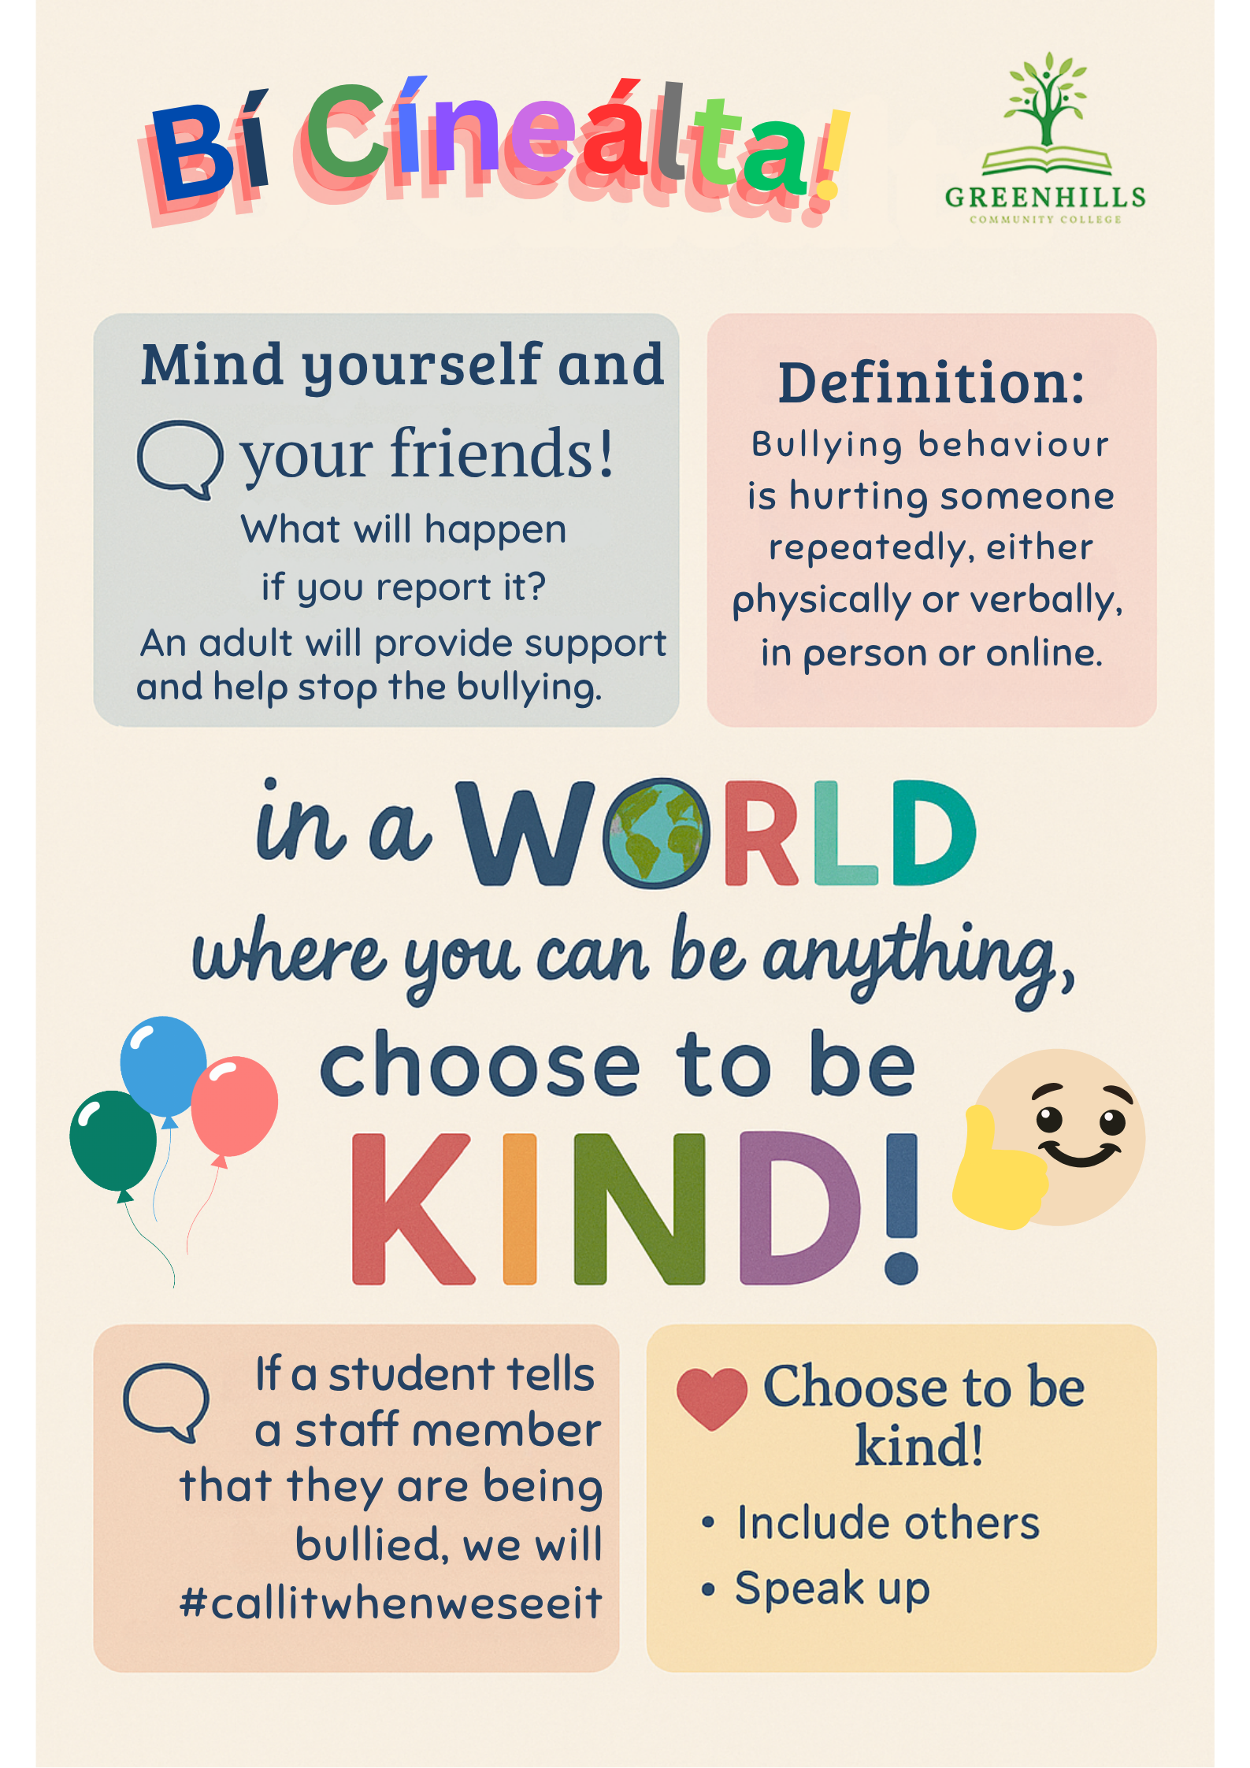

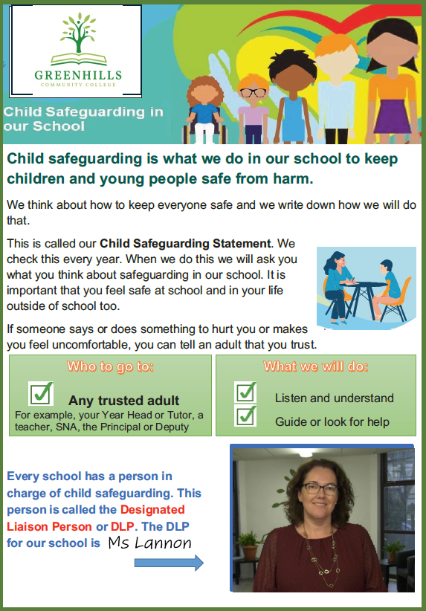

RESTORATIVE PRACTICE



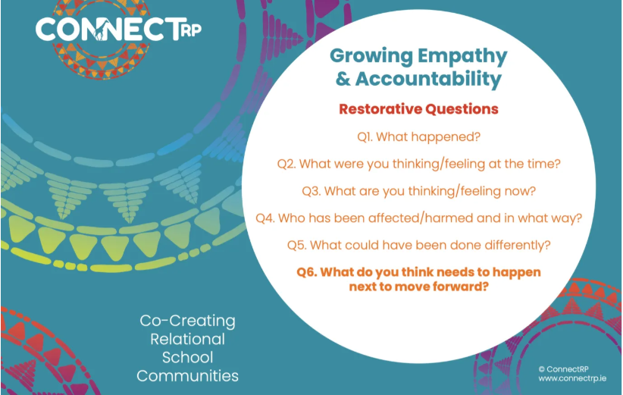

SCHOOL ATTENDANCE:
We would like to inform you a little about the Education Welfare Act, 2000 (amended by the Child and Family Agency Act 2013) and about some of the responsibilities we share under the Act.
As you know, a good education gives your son the best possible start in life. A good education helps young people to obtain secure employment and develop into mature and responsible citizens. The purpose of the Education (Welfare) Act 2000 is to encourage regular school attendance and participation in education and training for as long as possible. It is desirable that every child stays in school and completes the Leaving Certificate.
Under the law, every child must attend school regularly up to sixteen years of age or complete at least three years education in a post primary school whichever comes later.
As a parent, you must let the school know if your son is absent and the reason why. It is school policy that reasons must be given in writing. The school will notify Tusla (Child and Family Agency) if a child is absent for 20 days or more or where the absence gives rise to concern.
If your son is sick or is absent for other good reasons, no action will be taken by Tusla. However, if there is concern about your son’s attendance at school or about the reasons given, you may be visited by an Educational Welfare Officer who will discuss your son’s education with you. The Officer will work with you and take full account of the circumstances of the child and the family before deciding what further action is necessary to ensure that the child receives his entitlement to an education.
Further information concerning the new service and about school attendance matters generally can be obtained from the national Lo-Call Education Helpline - 1890 36 36 66.
Supports from HSCL and SCP are provided to students and families where attendance is a concern. Parents/ Guardians will be contacted and visited by HSCL to offer support regarding attendance.
Students are expected to attend daily in order to make the best use of the opportunities available.
- Attendance at school is a legal requirement in accordance with the Education (Welfare) Act 2000. Students must attend each school day. Under the Education Welfare Act, the school is obliged to report absences totalling more than 20 days to the Education (Welfare) Board.
- Students are not permitted to leave the school grounds, in the morning and at lunchtime.
- If, for any reason, a student has to leave school early, written permission from parent/guardian must be given beforehand in his journal. The journal must then be presented to the Year Head/Deputy Principal/Principal before leaving the school.
- In the notes section of the journal, a note signed by a parent/guardian and conveyed to the class tutor must explain absences from school.
- No student may leave the school premises during the school day without the correct authorisation.
- No student may absent himself from class without the class teacher’s permission.
- Attendance at all school activities is obligatory for those involved.
- Returning late after lunch (for senior students) will result in a detention.
- Students must sign out at the office when leaving the school building early during the day.



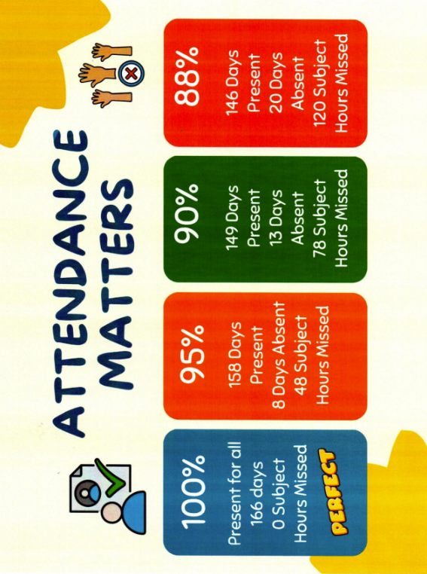

PUNCTUALITY
Punctuality is essential to school life as it leads to a better learning environment for all. Students must arrive punctually for the start of the school day i.e. before 9am in the morning and before 2pm after lunch ( Transition Year, 5th and 6th year groups are permitted to leave the school during the lunchtime break)

LATE FOR SCHOOL
- Students who are regularly late at 9 a.m. (an accumulation of two lates) must attend detention.
- Students who are late back after lunch will receive an automatic detention.
- Parents/guardians of students who are regularly late will be invited to the college to discuss how their son's lateness can be resolved.
- The student journal should be signed each week by a parent or guardian.
- The student journal should be used only for the above purposes.
- It is the student’s responsibility to catch up on any homework given during his absence.

COMMUNICATION
Communication is essential for the effective running of the school.
- Letters from the school addressed to parents/guardians should not be opened by students and should be delivered promptly.
- Telephone calls to and from parents/guardians should be made through the office and not on personal mobile phones.

ELECTRONIC & DIGITAL DEVICES
- Personal devices must be switched off and put away as soon as the student enters the school grounds. Personal devices including Mobile Phones, Gaming Devices and iPads, are not allowed in the canteen or on the corridors.
- All electronic devices are strictly forbidden during class time unless authorised by the class teacher to assist with teaching and learning.
- The use of these items at unsanctioned times will result in their confiscation (see Mobile Phone Policy).
- Mobile phones must be turned off during the day. Breach of this rule will result in confiscation of the phone. (See Digital Learning and Acceptable Use Policies)
- Students are not permitted to use iPads and other devices for non-academic purposes without permission in class.
Unauthorised filming/photography/ recording in school and on school trips will result in a suspension from school.

- If a student refuses to hand over a phone (seen or heard during class-time, in the canteen, sports hall or on the corridors) to the teacher the student will receive an automatic detention and will be referred to the Deputy Principal or Principal. At this stage any refusal to hand over the phone will result in the student automatically proceeding to Level 3, Suspension. However, the overall is recorded as only receiving the next level on the ladder. If a student has their phone confiscated on any further occasions their parent/guardian must collect the phone the following working day.
See additional notes after the Ladder of Referral

HOMEWORK AND JOURNAL
Homework reinforces school work and learning. It should be completed to ensure that students make the most of their opportunities to get a good education. The school journal is an important home/school link. Begin each week by identifying short term goals. It is important to record time spent on homework.
- All students are obliged to have a student journal in which they must record homework, class work, and teacher’s comments, notes regarding absences, late-coming and appointments. Students must have their journal with them every day. The journal must be kept free from graffiti. Defaced journals will be confiscated and students will have to replace them at a cost of 15 euro. Remember your journal is the most important item you have for school every day. Your journal reflects your commitment to school rules.
- Pupils must produce their journal at the beginning of each class and keep it on their desk throughout each class.
- Homework must be completed. If not, the homework journal must be presented to the subject teacher with an explanatory note from a Parent/ Guardian. Two homework notes will result in a detention and so on.
- Non completion of Homework will result in a Homework note. Two homework notes will result in a detention and so on.
- Teachers will record Positive notes in the journal to commend Students on excellent work or class participation.

TEXTBOOKS, EQUIPMENT
- All textbooks and a stationery pack are provided to every student through the Free Book Scheme.
- All students must have the required textbooks, exercise books, pens, etc. for each class.
- Money or other valuable objects should not be left in lockers, coats or bags.
- Failure to present to class without the proper equipment will result in an organisational note.

LOCKERS
- Students have access to a school locker. Lockers may only be visited before 9a.m, during small break and at lunch break each day. Students are required to have their books organised before the bell rings.
- Students should ensure that their locker is locked at all times.
- Students who do not vacate the locker area by 9am, 11.20 (11.10 on Wednesdays or 2pm will receive a late note in their journal. This will count as a Behaviour note.

TOILET BREAKS
- Students may not visit the toilets between classes. Students are permitted to use the toilets between 8.30 a.m. and 9 a.m., during morning break and at lunch time.
- If a student needs to visit the toilet during class time, for exceptional/medical circumstances, a note is required from a parent/guardian. Students must go to the main office to sign for and collect the key.
- Students are not permitted to visit the toilet between class periods. Students must go from class to class without delay.

HEALTH AND SAFETY STATEMENT
All members of the school community have the right to work in a safe and healthy environment and each student has a responsibility to contribute positively to that environment.
- Students must adhere to all hygiene procedures in the college
- Cigarettes, Vapes, matches, lighters, alcohol and other controlled substances are strictly forbidden in school, on school grounds or vicinity, during all school-related activities and on all occasions where the school uniform is worn.
- The use or handling of any illegal substance, or fireworks is strictly forbidden.
- All bikes must be parked and locked in the Bike Shed during school hours.
- Chewing gum is not allowed on the school premises.
- Fizzy drinks and energy drinks are not allowed on the school premises
- Using tippex or similar fluid and felt pens are strictly forbidden.
- All food and/or drink to be consumed in the school canteen only. Eating and/ or drinking is forbidden in classrooms or on corridors.
- Safety equipment and notices of any kind must not be interfered with.
- Students are asked to move between classes quietly, without running.
- Boisterous behaviour will not be tolerated.
- All pupils are responsible for the condition of the school building and grounds. Wilful damage to property or theft will result in severe disciplinary action and full compensation must be made by those responsible.
- Graffiti is prohibited.
- Littering is prohibited.
- Students bringing a moped, motor cycle or car to school must obtain permission from the Principal before entering the school grounds.
- Pupils must remain within the designated play areas assigned to them.
- During class time student movement throughout the school is only permitted by obtaining a note from the class teacher which is recorded in the journal.
- The Board of Management has adopted and implement fully the Department’s Child Protection Procedures.
- The Designated Liaison Person (DLP) is the Principal Ms. Noirin Lannon.
- The Deputy Designated Liaison Person (DDLP) is the Deputy Principal Ms. Geraldine Leahy.
- Parents/Guardians are permitted to drop off their son in the front carpark. Please refrain from blocking the school entrance at all times of the day.
- Students arriving to the school before 8:30am will be required to wait in the designated yard to the rear of the college.
- Students may use the pedestrian gate at the main entrance to gain access to the school building.

Students are expected to behave in such a way as not to put their own safety or that of anyone else at risk. To help ensure this they are required to:
• Take reasonable care in the school and the school grounds to ensure their own safety and that of others.
• Not to leave the school grounds during school hours without permission. if they must leave a note should be given to the Year Head or students must contact home through the front office before leaving the school.
• Familiarise themselves with the designated emergency exit route from each room that they use, and the congregation and counting area at safety drill.
• Refrain from interfering with safety equipment such as fire alarms, fire extinguishers and hose reels.
• Refrain from littering the school building or grounds, all accidental spills should be reported immediately to a member of staff.
• Must obey all verbal and written safety instructions given to them by staff members.

Fire Safety
It is the responsibility of each student to familiarise himself and to comply with the fire drill.

Fire Drill
When the alarm sounds:
Students beside windows close windows, Walk quickly in single file towards your exit, Do not take personal belongings, The last person to leave the room should close the door.

At the Assembly point
Look around for students who were with you in your class and if someone is missing inform the teacher immediately. All teachers will do a head count and roll call.

If in toilets…
Move with the traffic flow to the assembly point and join your class group. You must be aware of exit routes from every room in which you have a class.
You must never absent yourself from class.

VERY SERIOUS BREACHES OF SCHOOL DISCIPLINE
Very Serious breaches of school discipline:
- Aggressive behaviour to staff either physical and/or abusive language.
- Fighting/Violence in school.
- Discrimination, harassment and/or sexual harassment in accordance with the Equal Status Act 2000.
- Bullying.
- Theft.
- Smoking/Vaping/ use or possession of alcohol and/or controlled substances.
- Un-authorised filming/photography in school.
- Failure to hand up mobile phone/personal stereo when requested to do so.
- Vandalism to school property or other student’s property.

Following consultation with the Parent/Guardian, the above will result in an automatic period of suspension. The student along with their Parent/Guardian may be called in front of the Board of Management for final warnings

SERIOUS BREACHES OF DISCIPLINE
Serious breaches of school discipline include the following:
- Poor behaviour in the yard
- Showing disrespect to any staff member.
- Refusing to follow direct instruction given by members of staff.
- Interference with fellow students’ right to learn.
- Disruption of class e.g. continuous talking in class.
- Unruly behaviour.
- Copying at exams.
- Forging parents’/guardians’ signatures.
- Failure to produce journal when asked.
- Not having school journal.
- Failure to produce reflection / reflective work.
- Failure to appear for detention (automatic suspension if a valid reason in writing from parent/guardian is not given).
- Failure to have note from teacher signed by parent/guardian.
- Defacement of school property.
- Vandalism to other student’s property.
- Littering.
- Missing school/class without appropriate authorisations.
- Forging notes to explain truancy/absence.
- Continuous lateness.
- Eating and/or drinking in classrooms or corridors.
- Wearing earrings and/or facial jewellery.
- Inappropriate hairstyle.
- Chewing gum.
- Using tippex and/or markers.
- Leaving school premises at any time during the school day without permission.

In line with the Ladder of Referral protocol, a serious breach of school discipline will result in a period of Suspension, following consultation with parents/guardians.

OTHER BREACHES OF DISCIPLINE
Other breaches of school discipline include the following:
- Failure to present homework.
- Incomplete work/homework.
- Copying of homework.
- Failure to have correct books for class.
- Late-coming (Consideration will be given to students relying on public transport or where there are any other extenuating circumstances)
- Failure to wear school uniform
- Failure to provide relevant notes.
- Failure to have journal signed weekly by parent/guardian.
- Failure to have mobile phone turned off during school hours.
- Running on corridors.
- Tussling in line outside class.
- Visiting toilets between classes without permission/ or corridor pass.
Note: Persistent misconduct will be treated as a serious breach of school discipline. These lists do not claim to be comprehensive.

SOME PROCEDURES FOR DEALING WITH MISCONDUCT
1. Misconduct in the classroom will be dealt with by the class teacher in the first instance.
2. A note informing parents/guardians may be written in the homework journal. Poor behaviour notes will move students along the Ladder of Referral.
3. Repeated misbehaviours will result in a student moving further up the ladder of referral.
4. Persistent misbehaviour will be reported to the Year Head.
5. A student may be put on detention and/or report to closely monitor his attendance, behaviour and/or work effort.
6. A student may be given a programme of work to follow at home.
7. A student may be referred to the Senior Management Team. Suspension may occur at the discretion of the Principal/Deputy Principal.
8. Certain circumstances may warrant the immediate removal of a student from class by a member of the Management Team.
9. In the event of very serious or a serious breach of discipline the process of sanctions may start at level 3 on the Ladder of Referral or the Senior Management Team or require the immediate referral to the Board of Management.
10. Suspension from class may occur when a student has been consistently uncooperative, disrespectful or disruptive during the day. Parents/Guardians will be informed and the student may be removed from school.
11. The Board of Management reserves the right to expel students in extreme circumstances.

DAYS OF DETENTION
Detention may be used as a result of a breach of school discipline in line with the Ladder of Referral.
After School Detention will take place on Tuesday and/or Thursday from 4pm to 5pm. If a student is absent on their assigned detention day, detention will take place on the next available day. This may be Tues/Thurs after school or at lunch time during the school day.
Year Head/Deputy Principal Detention will take place on Wednesday’s from 1.30 – 3.30.
Notification of detention outlining the reason for the detention will be given to the student by the Year Head/Deputy Principal/Principal.
A text will be sent to the parent(s)/ guardian(s) prior to the detention taking place.
Students must present promptly for detention at the allocated time and to the allocated room.
While on detention the student will be given work by the teacher in charge. This work must be completed fully during the period of detention failure to do so will result in further detention or suspension.
Any disruptive or unruly behaviour e.g. talking, disrupting the class, disrupting detention will be treated as a serious breach of discipline, which may lead to suspension.
Non-completion of detention at any level on the Ladder of Referral will result in a student being automatically moved to the next level on the Ladder of Referral.

PROCEDURES FOR INFORMING PARENTS/ GUARDIANS OF SUSPENSION
Parents/guardians will be informed in writing or by phone
(a) Of the reason for suspension
(b) Of the period of suspension
(c) That the student will be regarded as being in the care of the parents/guardians from the end of the school day in which he was suspended
(d) Students must complete all Reflection/reflective work assigned at home.

The Education Welfare Board may be informed of a student’s suspension in accordance with the Education (Welfare) Act, 2000, (24-(1)).
School management reserves the right to expel students in extreme circumstances in accordance with the Education (Welfare) Act, 2000, (24-(1)).
Should parents/guardians or students aged 18 or over wish to appeal against a decision to suspend or expel, procedures in accordance with the Education Act must be followed.
Suspensions may be appealed to the Principal in the first instance and thereafter to the Board of Management. The school may insist that the student remain at home while an appeal or suspension is being heard. Where a suspension may already have been served before the appeal is heard, in such cases where the appeal is successful, the record of suspension will be removed from the student’s file.
In Greenhills Community College fair procedures will apply to the investigation of alleged misbehaviour that may lead to suspension or expulsion. Fair procedures are based on the right to be heard and the right to impartiality.

PHYSICAL EDUCATION
- Students must wear the school PE uniform (navy tracksuit bottoms and school T-shirt); a note is required if gear is missing.
- Students must participate in all lessons unless excused with a note; non-participation may result in alternative work and/or a sanction.
- Students must show respect, teamwork, and good sportsmanship; bullying or inappropriate behaviour is not tolerated.
- Students are not permitted upstairs in the sports hall without permission or supervision.
- Students may only use the changing rooms with permission.
- Students must follow instructions and use equipment safely; unsafe behaviour may result in removal from the activity.

While wearing the school uniform, all students are expected to behave in line with the school’s Code of Behaviour at all times.

Although Greenhills Community College operates a fair and incremental Ladder of Referral some cases warrant immediate sanction. Greenhills Community College has laid out the Ladder of Referral on the following pages. Students and parents/guardians should read through the Ladder of Referral.

SANCTIONS FOR UNACCEPTABLE BEHAVIOUR
Record in Journal  Teacher records and deals with as appropriate | Immediate Detention  Teacher to record in journal and Year Head issues detention. | Suspension  Some behaviours may warrant suspension (following investigation and contact with the Parent/Guardian, Principal or Deputy Principal)
- Lates: 2 lates to school = Detention  - A late note to any class will count as a Behaviour note.  - No Homework/ Incomplete Homework -2 Notes = Detention  - 3 Behaviour notes = Detention and level 1 on Ladder of Referral  - 3 Organisational notes = 1 Behaviour note  - Copying homework  - No books/equipment  - Failure to get journal signed weekly  - Inappropriate behaviour in corridor  - On corridor with no permission  - Disrupting class with poor behaviour  - Not working in class  - Using bad/inappropriate language in the class/corridor/ canteen  - Constantly talking in class  - Slagging other students (see Anti-Bullying Policy)  - Chewing Gum  - Eating/drinking in class/corridor without permission  - iPad not charged sufficiently at the start of the school day | - Disrespectful to staff  - Not following instructions – disobedient  - Repeatedly preventing other students from learning in class and online  - Failure to wear full school uniform  - No journal in class  - Refusal to hand up journal to the teacher when requested  - Forging parent/ guardian signature  - Failure to produce Reflection /reflective work  - Missing from class without permission/note  - Dangerous behaviour in class  - Not leaving the canteen on time  - Left class without permission  - Defacing the journal  - Not returning to school after lunch  - Returning late after lunch  - Refusing to put mobile phone away  - Refusing to hand up mobile phone to teacher  - Refusal to remove facial jewellery  - No school bag | - Continuous disrespect towards  staff  Disruption and poor behaviour on school trips  - Any action that endangers the wellbeing of staff and students  - Aggressive behaviour (Physical/verbal)  - Spitting  - Verbal abuse of a member of staff  - Intentionally coughing or spitting on staff and students  - Bullying (After investigation)  - Sexual Harassment  - Discrimination  - Using discriminatory language  - Refusal to hand up mobile phone to Principal or Deputy Principal  - Cyber bullying of staff/student  - Refusal to do Year Head’s Detention  - Fighting  - Theft  - Recording and taking photos using any electronic device  - Smoking/Vaping, Use or possession of alcohol and/or controlled substances Vandalism of school/student property  - Leaving designated area of school or school grounds without permission.  - Refusal to accept and wear school uniform supplied by the school.
This list is not exhaustive and other serious misconducts will be dealt with at the discretion of the school management.
LADDER OF REFERRAL
The following Ladder of Referral is provided to inform staff, parents/guardians and students of the sanctions which will be applied if the school’s Code of Behaviour is not adhered to. The Ladder of Referral sets out the level, sanctions and actions to be taken and the support measures which will be put in place to support the students of Greenhills Community College. At any level, internal and external supports will be offered to the parent/guardian and student. A record of the ladder will be maintained in the student’s journal and on school files. School files will also record the supports offered. Students can buy back a level if their behaviour is monitored as good for a consecutive two week period.
Please note: *In line with our Code of Behaviour VERY SERIOUS BREACHES will result in an automatic period of suspension.

Level 1 : After School Detention
(3 behaviour notes in 1 week) class tutor will provide guidance at tutor time to students on 2 notes. Level 1 is broken down into level 1A, 1B and 1C.
Action: Text message will be sent to the parent/guardian
Sanction: After school detention (Tuesday or Thursday 4 to 5pm)
Follow up: Parent/guardian called to see Year Head if not completed within the week.
Non-completion of detention at level 1A, 1B or 1C student will be automatically moved to Level 2. The student should complete a Year Head’s Detention.

Level 2 : Year Head Detention
(3 behaviour notes in 1 week) class tutor will provide guidance at tutor time to students on 2 notes. Level 2 is broken down into level 2A, 2B and 2C
Action: Text message will be sent to the parent/guardian
Sanction: After School Wednesday detention for 2 hours with Year Head/Deputy Principal
Follow up: Parent/Guardian informed by text the day before the sanction is applied.
Support
Measure: Students may be offered Restorative Practice with a trained member of staff, during this time.

Non-completion of Year Head Detention at level 2A, 2B or 2C student will be automatically moved to Level 3. The student will receive a 1 day suspension.

Level 3, 4, & 5 : Suspension
(3 behaviour notes in 1 week) class tutor will provide guidance at tutor time to students on 2 notes.
Action: Parent required to attend a meeting or to discuss the issue over the phone with Year Head and or Deputy Principal or Principal.
Sanction: Suspension, duration of which to be decided by the Principal in line with the Code of Behaviour and NEWB Guidelines
Support measure: The student may be offered a session of Restorative Practice. The student, parent/guardian will be offered internal support and or referred to external agencies where necessary. The Student will be placed on a target card and will report to Year Head each day for a duration set with the parents/guardians. Students who are on Level 5 and then continue to breach the Code of Behaviour will be referred to the Senior Management Team.

Level 6: Referral to Senior Management Team (Principal & Deputy Principal)
(3 behaviour notes in 1 week) class tutor will provide guidance at tutor time to students on 2 notes. :
Action: If a student is presenting with ongoing behavioural issues the parent/guardian and student will be required to attend a meeting with the Senior Management Team, consisting of the Principal, Deputy Principal and an Assistant Principal. Nonattendance at this meeting will result in the presentation of the student’s file to the Board of Management. The student's file will be available for the team to review. Following this meeting, recommendations will be made and an individualised plan to support the student will be put in place. If there are further breaches of the Code of Behaviour the student will be referred to the Board of Management.

Level 7: Board of Management
Following referral to the Board of Management the student and parent/guardian will be required to attend the Board of Management meeting.
Additional points:
- The use of verbally abusive language towards a member of staff moves a student straight to Level 3 sanction. But the overall sanction is recorded as only receiving 1 level on the ladder.
- Refusal to hand up a journal results in an automatic Level 1 (and if already under sanction, the student proceeds to the next Level).
- Students found to be using an electronic device in toilets or changing rooms to record footage/take images of other students will be suspended and the case will be referred to the Principal.
- Students found to be using an electronic device to record footage/take images of staff without their consent will be referred to the Principal.
- Student’s found to be uploading these images/footage to social media platforms will be suspended and the case will be referred to the Principal for consideration.
- Any students leaving school without permission will result in an automatic suspension. This will move students onto the next level on their ladder of referral.
- Any student who arrives late to class, without a valid written reason from their previous teacher, will receive a note in their journal. This will count towards their weekly notes.
- Students who do not vacate the locker area by 9am, 11:20 (11:10 on Wednesday) or 2pm will receive a late note in their journal. This will count as a behaviour note.
- 3 Behaviour Notes = 1 Level on the Ladder of Referral
3 Organisational Notes = 1 Behaviour Note
2 Homework Notes = 1 Detention

This list is not exhaustive and other serious misconducts will be dealt with at the discretion of the school management.
Immediate Year Head Detention can be given to any student who continually disrupts teaching and learning and displays disruptive behaviour in the school. If students require more active interventions to help them manage their behaviour, additional supports will be put in place for them. Many students who display challenging behaviour and may have great difficult learning new behaviour may find it difficult to respond to some interventions. These students are referred to the various members of staff, Year Heads and Guidance services where appropriate.
Students who have presented with the below organisational, homework and punctuality issues will be referred to the Care Team
- Above 10 Homework notes in an academic year.
- Above 10 Organisation Notes in an academic year
- Above a 30% of days with late notes in an academic year
Support will be provided to the student and parents through SCP intervention and in-school supports.
Should the students’ patterns not improve after the interventions provided by the Care Team, the school reserves the right to refer the concern to the Tulsa Educational Support Services.
Ladder of Referral Personal Record

LEVEL | SANCTION | DATE COMPLETED | SIGNATURE  (YR HD/DP/P) | SIGNATURE  (PARENT/  GUARDIAN)
1A | After School Detention
1B | After School Detention
1C | After School Detention
2A | Year Head Detention
2B | Year Head Detention
2C | Year Head Detention
3 | Suspension
4 | Suspension
5 | Suspension
6 | Senior Management Team
7 | Board of Management

Please note:
If a student does not receive a behaviour note for 2 consecutive academic weeks, he will move back 1 space on the ladder of referral. Please see following page for a record of this.
Parents/guardians are reminded to keep an eye on this page. Please sign each section in the appropriate column following a sanction.

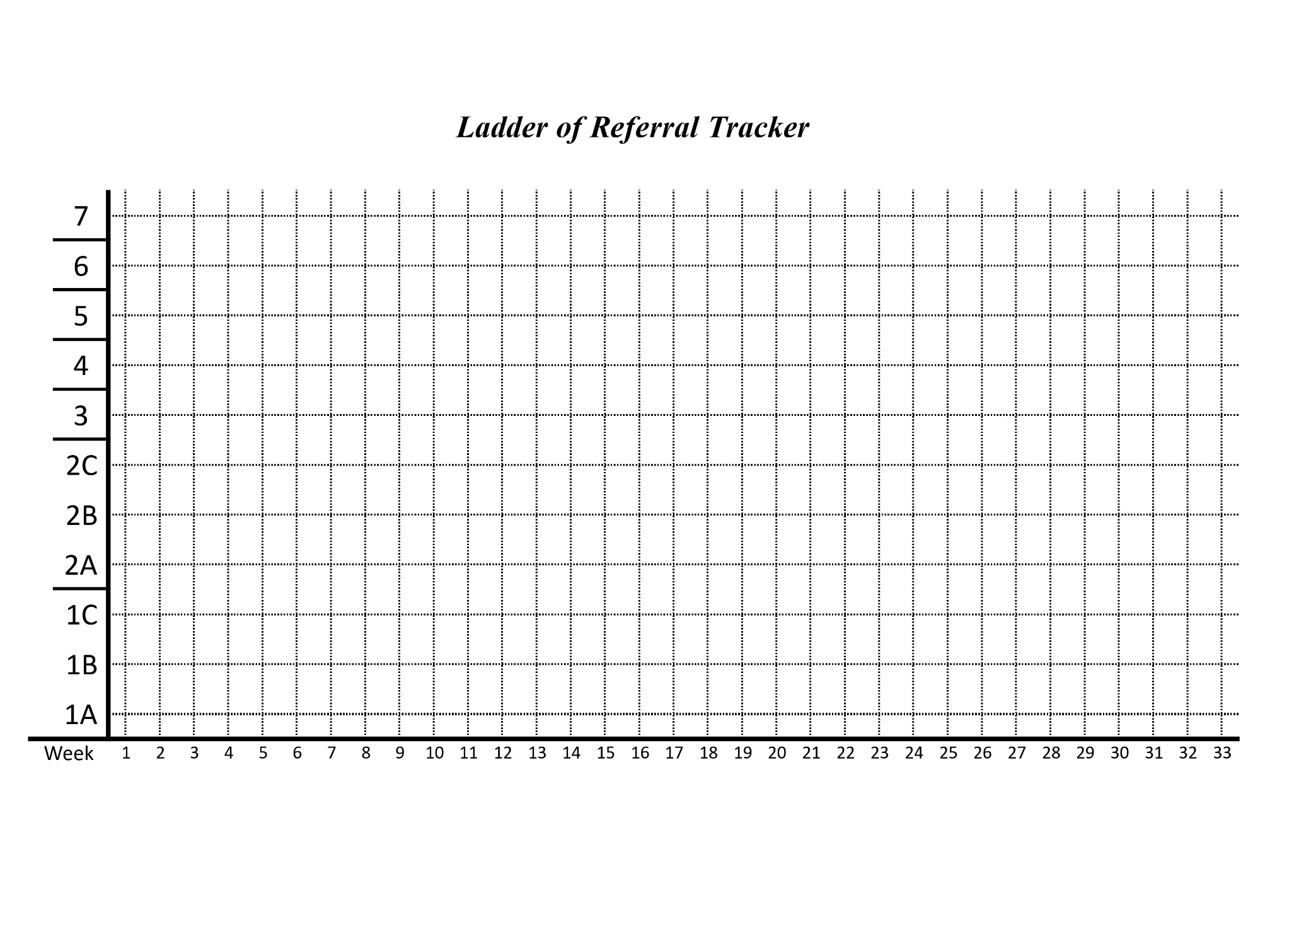

Declaration:
This policy was formed following consultation with staff, members of the Board of Management, Parents and Students.
It is recommended that this policy be reviewed every three years or whenever it is deemed necessary by School Management.
It was adopted by the Board of Management of Greenhills Community College on: 14 May 2026

Signed: Pamela Kearns Date: 14 May 2026

Chairperson, Board of Management

Signed: Noirin Lannon Date: 14 May 2026

Principal, Greenhills Community College

