Greenhills Community College

Transition Year Policy
2026

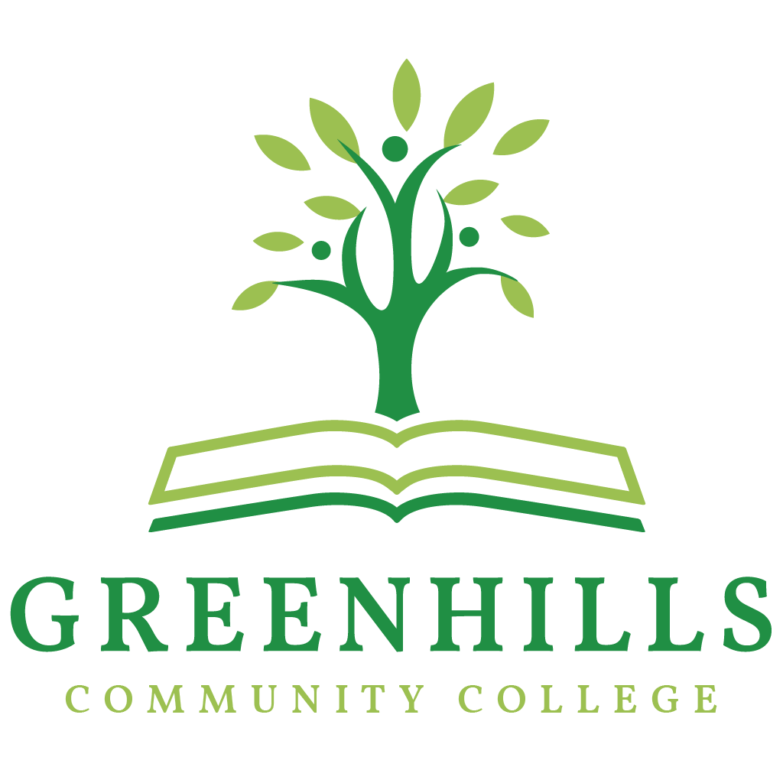

Mission Statement
At Greenhills Community College, we promote academic excellence, in a respectful and inclusive environment, where learners achieve their unique potential.
We encourage a culture of curiosity, helping our students flourish into responsible individuals, who embody the core values of our school.
We Care. We Prepare. We Achieve.

Aims and Objectives
- To create an environment that facilitates student learning through a wide variety of teaching strategies and activities.
- To provide the most rewarding education possible and make the process of learning an enjoyable experience.
- To provide a comprehensive integrated education that will enable each individual to fulfil their potential in a positive, caring, respectful, learning environment where skills and attitudes for life-long learning are developed.
- To operate the College as a partnership between the staff, students, parents and the wider community in accordance with the Education Act 2018 and the Education Welfare Act 2023.
- We aim to establish an inclusive work environment free from discrimination in accordance with the Equal Status Act 2018.

Background
Greenhills Community College, an all-boys second-level school, was opened in 1970 to serve the developing area of Southwest Dublin. The college seeks to stimulate and foster the physical, intellectual, moral, emotional and spiritual growth of the students. Parents/ Guardians who choose Greenhills Community College as a second-level school for their children do so in the knowledge that the college will value each student for their own personal gifts. Today the college is up-to-date and is well equipped to meet the challenge of preparing our young people for a successful future. The college is multi-denominational and welcomes students from all religious and cultural backgrounds.

Board of Management:
- Three nominees of Dublin & Dun Laoghaire Education & Training Board
- Two parent representatives
- Two teacher representatives
- Three Community representatives
- The College Principal acts as Secretary to the Board

Current Management Structure:
- Principal: Ms. Noirin Lannon
- Deputy Principal: Ms. Geraldine Leahy
- Assistant Principals 1:
  - Ms. Laura Fox
  - Ms. Margaret Brosnan
  - Ms. Mary McMahon
  - Mr. Ciaran Stone
  - Mr Tadhg Farrelly
  - Mr Sean Ennis
  - Ms Maria Donoghue
  - Mr Dave Waters

General Aims
“Transition Year offers schools time, space and autonomy to create enjoyable and meaningful educational experiences that support students in senior cycle. The programme aims to: Nurture the development of the student as a whole person. Create space and opportunities for meaningful, enjoyable learning experiences. Expand the student’s experience and awareness of diverse future pathways. Evolve continuously to support lifelong learning and development.” (Transition Year Programme Statement)

The Greenhills Community College Transition Year curriculum is one that will:
- Give students a broad education experience free from exam pressure to study new subjects and gain new experiences which the Junior and Leaving Certificates don’t provide.
- Promote the personal and social development of each student so that they become confident, responsible, well-adjusted adults.
- Help students discover and develop their own talents and gifts
- Offer Leadership Opportunities
- Provide Work Experience Opportunities
- Encourages Creativity and Entrepreneurship
- Help to develop Skills for Life
- Help to promote Maturity and Resilience

Code of Behaviour
- All behaviour should be adhered too as per the Greenhills College Code of Behaviour Policy which can be found on www.greenhillscollege.ie. The school tours and work experience policies must be adhered to also.
- Students not following the Code of Behaviour may as a result miss out on Excursions, class trips or events ran in the school.
- Students must be in full school uniform on Monday, Tuesday, Thursday and Friday and their own clothes on their Activities Day.
- Students must adhere to the Health and Safety policy when using the Kitchen and practical rooms.

Participation

- Transition Year is a one-year Compulsory programme in Greenhills Community College designed to facilitate the transition from Junior to Senior Cycles and to prepare for adult life.
- Students must engage in all classes, workshops and excursions.

Curriculum
The Core Subjects
English, Irish, Maths, Guidance & Well-being, Religion and SPHE.
Sampling Subjects:
Business, German, Art, History and Geography, Engineering and Science
Enrichment Modules
This may include:
- Leadership Programme for the Active school flag
- Health and fitness
- Enterprise: Mini Company
- Gardening
- Life Skills- such as Cookery and Driver Theory
- Career Planning and Preparation for the World of Work
- Sign language
- Screen printing
- Plumbing
- Music
- Korean

Activities Wednesday
Activities might include, Spawell driving Range, Dublin Zoo Conservation Workshop, Guided Tour of Croke Park, visits to the National Gallery, Glasnevin and Collins Barracks, Barista workshop, Drumming, Reptile visit, pizza making and many more.

Assessment and Evaluation
- Students must participate in all subjects that are offered during the term.
- Subjects will be assessed based on a credit system and completion of a portfolio. The portfolio will contain samples of the student's best work and reflective pieces.
- Work may take the form of a Project, Continuous Based Assessment, Presentations, tests, classwork etc.
- There will be Christmas and Summer Exams in the Core Subjects of English, Irish and Maths.
- Students will take part in key school events throughout the year; e.g. Awareness weeks, Market Day, Fundraising events, Seachtain na Gaeilge etc.
- There will be an award Ceremony at the end of the Academic Year to commend students on their Participation and Completion of the Transition year Programme.
- Students will receive a Distinction, Merit or Pass.
Work Experience
- For the academic Year 2026-2027 work experience will take place for four weeks, in two two week blocks.
- It is up to each student to find their own work placement, though family and friends.
- Work Experience will commence from the 1st week students are back to school.
- Students are insured under the school's insurance while on placement, however some employers may have other working conditions and require Garda Vetting.
- The school maintains close contact with all employers during the duration of the work experience.
- When the student returns their work experience information sheet, the Transition Year Coordinator will contact the potential employer and forward on all necessary information.
- Students are representing Greenhills Community College whilst out on ork Experience and therefore they should adhere to the Code of Behaviour.
- Students must bring their sign in booklets to work experience each day to be signed in.

Excursions
- Educational trips are regularly offered as part of the TY Programme. These may vary from year to year and involve overnight stays. These trips may include subject related trips and outdoor educational trips.
- Certain trips may incur additional fees, but students will be given notice as to where and when these will take place. Any trip that incurs an additional fee will be optional.
- School rules under the Code of Behaviour apply to all these trips and, in considering students’ eligibility for trips, our current Ladder of Referral will be looked at.
- In addition to this and specifically in relation to Outdoor Educational Trips organised, the following will also be taken on board in assessing students’ eligibility for inclusion on the trip - Any injuries or health-related matters which may impinge on the full and safe participation in the outdoor education programme.
- See the school tours policy for more information.

Finances
- Greenhills Community College Transition Year Programme is supported by student contributions of approximately €350 (Subject to change). Payments can be made in Full through the MIT System.
- Individual Payment plans can be set up if required. Please speak to the principal or school secretary.
- Payments must be received before the given date otherwise students may not be able to attend organised trips.
- There may be a trip to an overnight adventure centre which will depend on student demand. This is at an additional cost (for the centre and transport) and is not covered under the student contribution above.
- Students are encouraged to raise funds through various enterprise and fundraising activities during the year.

External Applications
- Any application to transfer to Greenhills Community College from another school will be considered strictly under the terms of the school’s Admissions Policy in relation to such transfers.
- Students must have completed 3 years Junior Cycle or the equivalent to enter the Transition Year Programme.
- To proceed into 5th Year in Greenhills Community College, transferring students must have completed 4 years of schooling at Post Primary Level or Equivalent.

Transition to LCE and LCA Senior Programmes
- As Transition Year is designed to act as a bridge between the Junior Certificate and Leaving Certificate programmes. This will greatly help students decide which Senior Cycle Programme they will attend in 5th Year.
- Our Guidance Department and subject teachers will offer support to students in deciding which programme and/or subjects to choose.
- Students must complete Transition Year to proceed into 5th Year.

Declaration:
This policy was formed following consultation with staff, members of the Board of Management, Parents and Students.
It is recommended that this policy be reviewed every three years or whenever it is deemed necessary by School Management.
It was adopted by the Board of Management of Greenhills Community College on: 14 May 2026

Signed: Pamela Kearns Date: 14 May 2026

Chairperson, Board of Management

Signed: Noirin Lannon Date: 14 May 2026

Principal, Greenhills Community College

